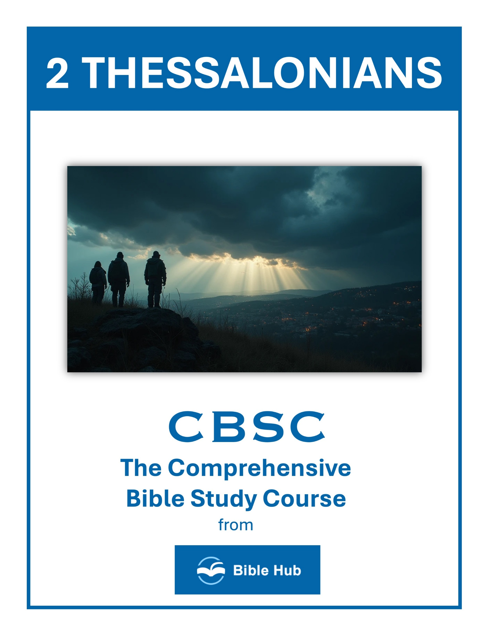

2 Thessalonians 1 Teaching Points and Bible Study Questions
Perseverance in Faith
In the face of trials and tribulations, the Thessalonians were commended for their steadfast faith. This is a powerful reminder that our faith is not just for the good times but is meant to be a rock during life's storms. As Paul writes, "We ought always to thank God for you, brothers, and rightly so, because your faith is growing more and more" (2 Thessalonians 1:3). Let this encourage you to hold firm in your faith, knowing that perseverance is a testament to your relationship with God.
1. How can you strengthen your faith when facing trials similar to those in 2 Thessalonians 1?
2. Why do you think perseverance in faith is crucial during challenging times, as seen in 2 Thessalonians 1?
3. What practical steps can you take to encourage others in their faith journey, inspired by 2 Thessalonians 1?
Love That Abounds
Paul highlights the increasing love among the Thessalonians, a love that is evident to all. "The love every one of you has for one another is increasing" (2 Thessalonians 1:3). This is a call to action for us to let our love for others grow and overflow, reflecting the love of Christ. In a world that often feels divided, let your love be a beacon of hope and unity.
1. How can you actively demonstrate love that abounds in your daily interactions with others?
2. Why do you think abounding love is essential for strengthening community relationships?
3. What practical steps can you take to ensure your love for others continues to grow?

Endurance as a Testimony
The endurance of the Thessalonians in the face of persecution serves as a powerful testimony to their faith. "Therefore, among God’s churches we boast about your perseverance and faith in all the persecutions and trials you are enduring" (2 Thessalonians 1:4). Your endurance can inspire others and serve as a living testament to the strength that comes from God.
1. How can your endurance in trials serve as a testimony to others in your community?
2. What do you hope others learn from observing your perseverance in difficult situations?
3. Why does enduring hardships strengthen your faith and impact those around you?
Righteous Judgment of God
Paul reassures the Thessalonians that God’s judgment is just and righteous. "God is just: He will pay back trouble to those who trouble you" (2 Thessalonians 1:6). This is a comforting reminder that God sees all and will bring justice in His perfect timing. Trust in His righteous judgment and find peace in His sovereignty.
1. How can you apply the concept of God's righteous judgment in your daily decision-making?
2. Why do you think understanding God's judgment can influence your interactions with others?
3. What can you do to align your actions with the principles of God's righteous judgment?

Relief for the Afflicted
For those who are suffering, Paul offers a promise of relief. "He will give relief to you who are troubled, and to us as well" (2 Thessalonians 1:7). This assurance is a reminder that God is aware of our struggles and will provide comfort and rest. Lean on Him and find solace in His promises.
1. How can you find comfort in God's promise of relief during times of personal suffering?
2. What do you hope to learn from enduring hardships with faith and patience?
3. Why does trusting in God's justice help you cope with life's challenges?
The Revelation of Jesus Christ
Paul speaks of the day when Jesus will be revealed from heaven. "This will happen when the Lord Jesus is revealed from heaven in blazing fire with His powerful angels" (2 Thessalonians 1:7). This is a powerful reminder of the hope we have in Christ’s return. Let this anticipation fuel your daily walk and inspire you to live with purpose and expectation.
1. How can you prepare your life for the revelation of Jesus Christ as described in 2 Thessalonians 1?
2. What do you hope to learn about justice and faith from the revelation of Jesus Christ?
3. Why does the promise of Jesus' revelation encourage perseverance in your daily challenges?

Eternal Separation for the Disobedient
Paul warns of the consequences for those who do not know God. "They will be punished with everlasting destruction and shut out from the presence of the Lord" (2 Thessalonians 1:9). This sobering truth calls us to share the gospel with urgency, so that others may come to know the saving grace of Jesus Christ.
1. How can understanding eternal separation motivate you to live a more obedient life today?
2. Why do you think eternal separation is a consequence for disobedience, and how does this impact your choices?
3. What can you do to help others understand the seriousness of eternal separation and encourage obedience?
Glorification of the Saints
When Christ returns, He will be glorified in His holy people. "On that day He comes to be glorified in His holy people and to be marveled at among all those who have believed" (2 Thessalonians 1:10). This is a beautiful promise that as believers, we will share in His glory. Let this inspire you to live a life that reflects His glory now.
1. How can you actively participate in the glorification of the saints in your daily life?
2. Why do you think glorification is important for the community of believers today?
3. What can you do to encourage others in their journey towards glorification?

Prayer for Worthiness
Paul prays for the Thessalonians to be counted worthy of their calling. "We constantly pray for you, that our God may make you worthy of His calling" (2 Thessalonians 1:11). This is a reminder to seek God’s guidance in living a life that honors Him and fulfills His purpose for us. Let prayer be your guide as you strive to walk worthy of your calling.
1. How can you incorporate prayer into your daily routine to seek worthiness in God's eyes?
2. What do you hope to achieve by praying for worthiness in your personal and spiritual life?
3. Why do you think praying for worthiness is essential for your growth as a believer?
The Name of Jesus Glorified
Ultimately, Paul’s desire is that the name of Jesus be glorified through the lives of believers. "We pray this so that the name of our Lord Jesus may be glorified in you, and you in Him" (2 Thessalonians 1:12). Let your actions and words bring glory to His name, reflecting His love and grace to the world around you.
1. How can you actively glorify the name of Jesus in your daily interactions with others?
2. Why do you think glorifying Jesus' name is important for your personal spiritual growth?
3. What practical steps can you take to ensure Jesus' name is honored in your community?

2 Thessalonians 2 Teaching Points and Bible Study Questions
Stand Firm in the Truth
In a world filled with distractions and false teachings, it's crucial to hold fast to the truth of the Gospel. Paul reminds us in 2 Thessalonians 2:15, "So then, brothers, stand firm and hold to the traditions we passed on to you, whether by word of mouth or by letter." This is a call to remain steadfast in the teachings of Christ, ensuring that our faith is rooted in the unchanging Word of God.
1. How can you actively stand firm in the truth amidst daily challenges and misinformation?
2. Why do you think holding onto truth is crucial for personal and community growth?
3. What practical steps can you take to reinforce your understanding and commitment to biblical truth?
Do Not Be Easily Shaken
Life can throw unexpected challenges our way, but Paul encourages us not to be easily unsettled. In 2 Thessalonians 2:2, he advises, "not to become easily unsettled or alarmed by the teaching allegedly from us." This is a reminder to anchor our hearts in the peace of Christ, trusting in His sovereignty over all circumstances.
1. How can you remain steadfast in your faith when faced with confusing or alarming information?
2. Why do you think it's important to discern truth from falsehood in today's world?
3. What practical steps can you take to avoid being easily shaken by external influences?

Recognize the Deception of the Lawless One
Paul warns of the coming of the lawless one, who will deceive many. In 2 Thessalonians 2:9-10, he describes this deception as "in accordance with the work of Satan, displayed in all kinds of counterfeit miracles, signs, and wonders." We must be vigilant, discerning truth from falsehood, and relying on the Holy Spirit for guidance.
1. How can you discern truth from deception in today's world, as warned in 2 Thessalonians 2?
2. Why do you think recognizing deception is crucial for maintaining your faith?
3. What practical steps can you take to avoid being misled by the "lawless one"?
The Power of God’s Restraining Hand
God's sovereignty is evident as He restrains the full force of evil until the appointed time. 2 Thessalonians 2:7 states, "For the mystery of lawlessness is already at work, but the one who now restrains it will continue until he is taken out of the way." This reassures us that God is in control, orchestrating His divine plan.
1. How can you recognize and respond to God's restraining hand in your daily decisions?
2. Why do you think God chooses to restrain certain events or actions in our lives?
3. What can you do to align yourself with God's protective and restraining power?

The Importance of Love for the Truth
Paul emphasizes the necessity of loving the truth to avoid deception. In 2 Thessalonians 2:10, he notes that those who perish do so "because they refused to love the truth and so be saved." Cultivating a deep love for God's Word protects us from falling prey to lies and leads us to salvation.
1. How can you actively cultivate a love for truth in your daily life?
2. Why do you think loving the truth is crucial for spiritual growth and discernment?
3. What practical steps can you take to prioritize truth over convenience or comfort?
The Consequence of Rejecting Truth
Rejecting the truth has dire consequences. Paul warns in 2 Thessalonians 2:11-12, "For this reason God will send them a powerful delusion so that they will believe the lie, in order that judgment may come upon all who have disbelieved the truth." This serves as a sobering reminder to embrace the truth wholeheartedly.
1. How can rejecting truth impact your daily decision-making and relationships with others?
2. Why do you think people choose to reject truth despite knowing its consequences?
3. What steps can you take to ensure you remain open to truth in challenging situations?

The Assurance of Salvation
Amidst warnings, Paul offers assurance of salvation to believers. In 2 Thessalonians 2:13, he expresses gratitude, saying, "God has chosen you from the beginning for salvation through sanctification by the Spirit and faith in the truth." This is a comforting reminder of God's eternal plan for those who trust in Him.
1. How can understanding God's promises in 2 Thessalonians 2 strengthen your assurance of salvation daily?
2. Why do you think Paul emphasizes standing firm in faith for assurance of salvation?
3. What practical steps can you take to hold onto the hope of salvation amidst challenges?
The Call to Glory
Believers are called to share in the glory of Christ. Paul writes in 2 Thessalonians 2:14, "He called you to this through our gospel, so that you might share in the glory of our Lord Jesus Christ." This is an invitation to live with purpose, knowing that our ultimate destiny is to be glorified with Christ.
1. How can you actively prepare for the call to glory in your daily life?
2. What do you hope to change in your life to align with God's call to glory?
3. Why does understanding the call to glory influence your perspective on current challenges?

Encouragement through Eternal Comfort
Paul offers encouragement through the eternal comfort found in Christ. In 2 Thessalonians 2:16-17, he prays, "May our Lord Jesus Christ Himself and God our Father, who loved us and by His grace gave us eternal comfort and good hope, encourage your hearts and strengthen you in every good word and deed." This is a reminder of the sustaining power of God's love and grace.
1. How can you find encouragement in eternal comfort during challenging times in your life?
2. Why do you think eternal comfort is essential for maintaining hope and perseverance?
3. What practical steps can you take to share eternal comfort with others around you?
Strength for Every Good Work
Finally, Paul encourages believers to be strengthened for every good work. In 2 Thessalonians 2:17, he prays for God to "encourage your hearts and strengthen you in every good word and deed." This is a call to action, urging us to live out our faith through acts of love and service, empowered by the Holy Spirit.
1. How can you draw strength from God to persevere in your daily responsibilities and challenges?
2. What practical steps can you take to ensure your actions align with God's purpose for good works?
3. Why do you think relying on God's strength is essential for accomplishing meaningful tasks in your life?

2 Thessalonians 3 Teaching Points and Bible Study Questions
The Power of Prayer
In 2 Thessalonians 3:1, Paul urges, "Finally, brothers, pray for us, that the word of the Lord may spread rapidly and be honored, just as it was with you." Prayer is a powerful tool that can accelerate the spread of the Gospel. By lifting up our voices to God, we invite His divine intervention in our lives and the lives of others. Make prayer a priority in your daily routine, and watch how it transforms your world.
1. How can you incorporate prayer into your daily routine to strengthen your faith and resolve?
2. What do you hope to achieve through prayer when facing challenges in your community?
3. Why does consistent prayer play a crucial role in supporting and uplifting others in their struggles?
Deliverance from Evil
Paul continues in verse 2, "And pray that we may be delivered from wicked and evil men; for not everyone holds to the faith." This verse reminds us of the reality of spiritual warfare. While we are called to love our neighbors, we must also be vigilant and seek God's protection from those who oppose His truth. Trust in God's deliverance and stand firm in your faith.
1. How can you actively seek deliverance from evil in your daily life?
2. Why do you think prayer is essential for protection against evil influences?
3. What practical steps can you take to support others in overcoming evil?

Faithfulness of the Lord
Verse 3 reassures us, "But the Lord is faithful, and He will strengthen you and guard you from the evil one." God's faithfulness is unwavering, and He promises to protect us from spiritual harm. Lean on His strength and let His faithfulness be your anchor in times of trouble.
1. How can you rely on the Lord's faithfulness in challenging situations today?
2. Why do you think trusting in God's faithfulness strengthens your daily life?
3. What practical steps can you take to remind yourself of God's faithfulness regularly?
Confidence in Obedience
Paul expresses his confidence in the Thessalonians' obedience in verse 4: "And we have confidence in the Lord that you are doing and will continue to do what we command." Obedience to God's commands is a testament to our faith. Strive to live a life that reflects His teachings, knowing that your actions speak louder than words.
1. How can you build confidence in your obedience to God's commands in daily life?
2. Why do you think obedience to God strengthens your faith and confidence in Him?
3. What practical steps can you take to ensure consistent obedience in challenging situations?

Love and Perseverance
In verse 5, Paul prays, "May the Lord direct your hearts into God’s love and Christ’s perseverance." Love and perseverance are essential qualities for any believer. Allow God's love to guide your actions and Christ's perseverance to sustain you through life's challenges. Together, they form a powerful combination that can overcome any obstacle.
1. How can you demonstrate love and perseverance in challenging relationships within your community?
2. Why do you think perseverance is essential in maintaining love during difficult times?
3. What practical steps can you take to persevere in love when facing personal trials?
The Value of Hard Work
Paul addresses the importance of work in verse 10: "For even while we were with you, we gave you this command: If anyone is unwilling to work, he shall not eat." Hard work is a biblical principle that honors God and benefits our communities. Embrace diligence in your daily tasks, knowing that your efforts contribute to the greater good.
1. How can you incorporate the value of hard work into your daily routine effectively?
2. Why do you think Paul emphasizes working quietly and earning your own living?
3. What can you do to encourage others to appreciate and practice hard work in their lives?

Avoiding Idleness
Verse 11 warns against idleness: "We hear that some among you are idle. They are not busy; they are busybodies." Idleness can lead to gossip and unproductive behavior. Stay focused on your responsibilities and use your time wisely to avoid falling into this trap.
1. How can you actively contribute to your community to avoid idleness in your daily life?
2. Why do you think Paul emphasizes the importance of work and responsibility in this chapter?
3. What practical steps can you take to encourage others to avoid idleness and be productive?
Encouragement to Persevere
Paul encourages the Thessalonians in verse 13: "But as for you, brothers, do not grow weary in doing good." Perseverance in doing good is crucial, even when it feels challenging. Keep your eyes on the eternal reward and continue to serve others with a joyful heart.
1. How can you apply perseverance in your daily challenges as encouraged in 2 Thessalonians 3?
2. Why do you think perseverance is essential for spiritual growth according to 2 Thessalonians 3?
3. What practical steps can you take to encourage others to persevere in their faith journey?

Dealing with Disobedience
In verse 14, Paul advises, "Take note of anyone who does not obey the instructions we have given in this letter. Do not associate with him, so that he may be ashamed." This instruction highlights the importance of accountability within the Christian community. Address disobedience with love and grace, aiming to restore rather than condemn.
1. How can you address disobedience in a community while maintaining love and respect for individuals?
2. What steps can you take to encourage accountability and growth in those who are disobedient?
3. Why do you think it's important to set boundaries with those who persist in disobedience?
The Peace of the Lord
Finally, Paul concludes with a blessing in verse 16: "Now may the Lord of peace Himself give you peace at all times and in every way. The Lord be with all of you." God's peace is a gift that surpasses all understanding. Seek His presence in every situation, and let His peace guard your heart and mind.
By embracing these lessons from 2 Thessalonians 3, you can strengthen your faith, enhance your daily walk with God, and positively impact those around you.
1. How can you actively seek the peace of the Lord in your daily challenges?
2. Why do you think maintaining peace is essential in your relationships and community?
3. What practical steps can you take to foster the Lord's peace in stressful situations?

